ITSupport247: Patch Deployment Report Guide
Version 1.1 | Luis Lazo | CMIT Solutions Santiago
Purpose: Diagnose failed patch installations by customer

📋 Step-by-Step Instructions
Step 1: Access ITSupport247 Dashboard
ConnectWise Login → Click **"Asio"**
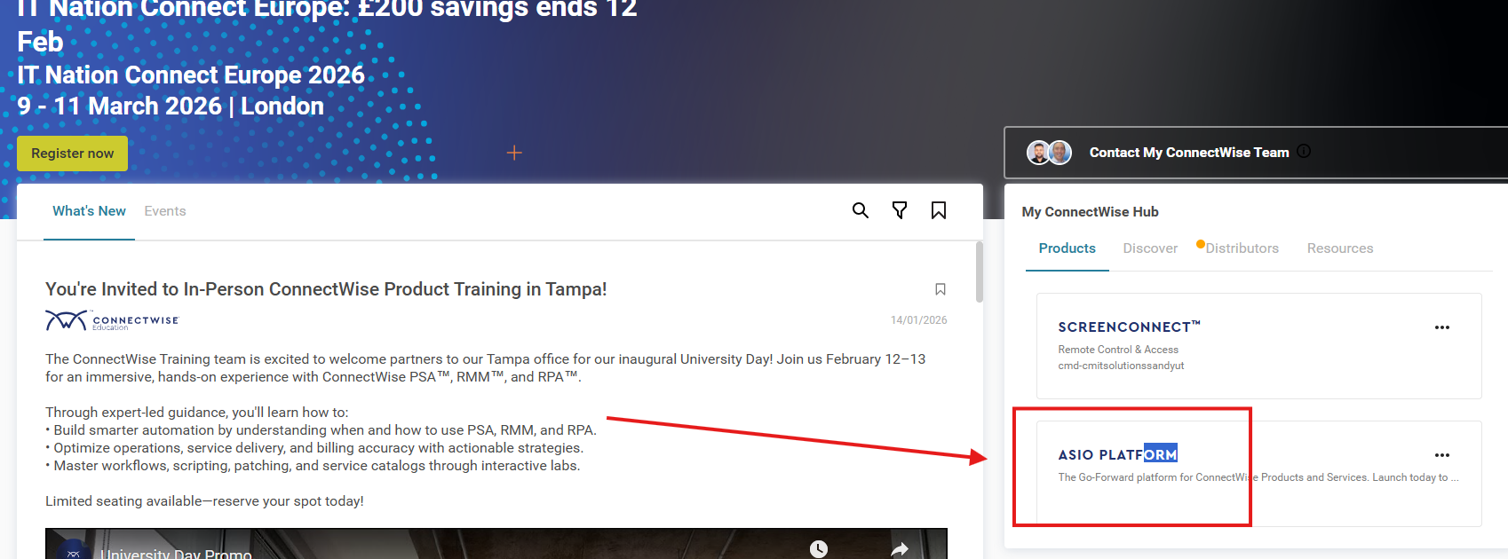Step 2: Navigate to Reports
ITSupport247 Dashboard → **"Reports"** section
Step 3: Patch Deployment Report
Reports → **"Disclose Patches"** → **"Patch Deployment Report"**
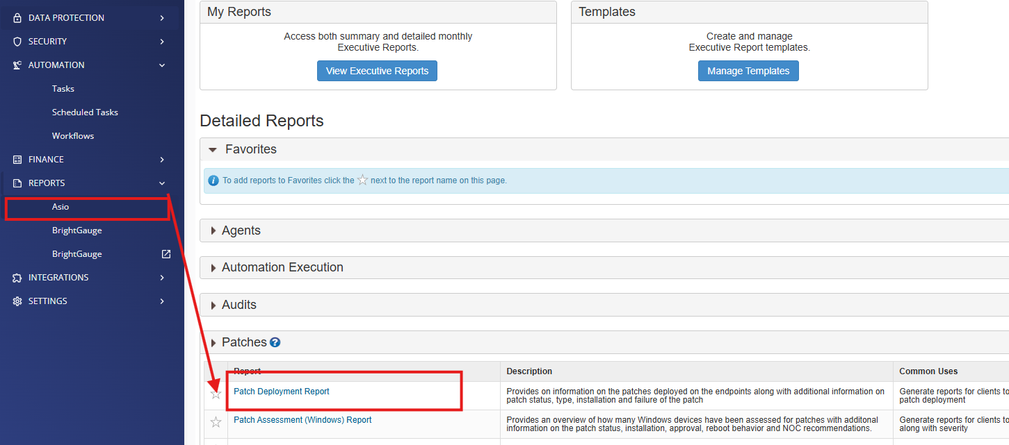
Step 4: Filter by Customer
**Customer Selection Dropdown** → Choose target(s):
- Individual client
- Customer group
- All customers
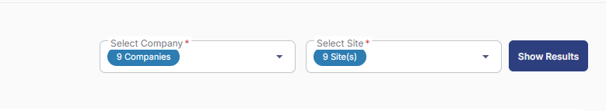Step 5: View Results & Diagnose
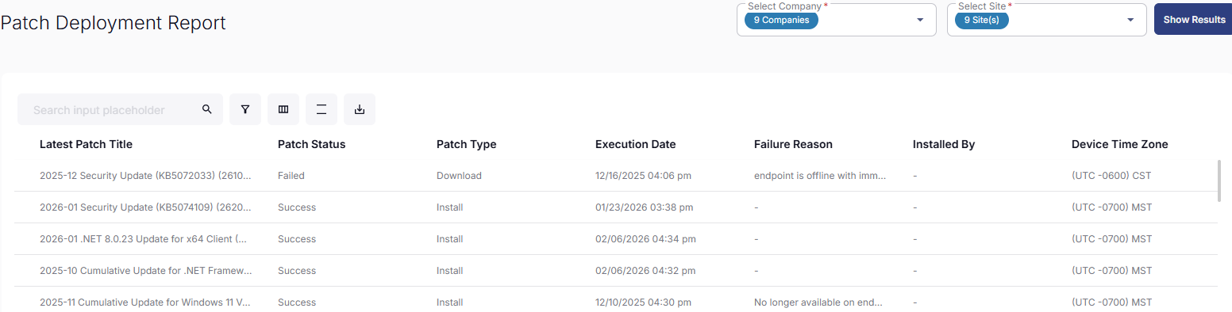
🔍 Common Failure Reasons & Fixes
❌ **Error 0x80070643** → .NET Framework conflict → Manual uninstall
❌ **Error 1603** → MSI conflict → Reboot + retry
❌ **Pending Reboot** → Force reboot policy
❌ **WSUS Sync Issue** → "Windows Patch Troubleshooter"

📊 Pro Tips
✅ Export to CSV for Jackson/tickets
✅ Filter by "Failed" status only
✅ Schedule weekly for compliance
✅ Screenshot → ConnectWise ticket

Author : Luis Lazo

